**ACTIVITY 1**

1. Open index.html on **Chrome**
2. Open the “**Elements**” tab of the developer’s tools (Ctrl + shift + I)

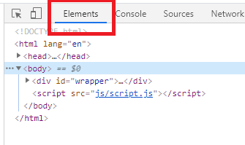

1. Answer following questions and **return your word documents on skype**:

Q1 – How many children has the element of id **add-book** ?

There are two element of id add-book.

Q2 – What is the **parent** of the element h2 “book to read”?

The parent of the element h2 is book-list.

Q3 – What are the ID and CLASS of element are used for?

-ID: wrapper, page-banner, search-books, add-book, book-list.

-Class: title, name, delete.

Q4 – Select the <div> of id “book-list” and delete it. What happens?

It will change the position of “Books to read” to left.